|  |  |  |
| --- | --- | --- |
| **Date** | 30/06/2025 | |
| **Team Id** | LTVIP2025TMID31504 | |
| **Project Name** | Medical Inventory Management | |
| **College Name** | Rise Krishna Sai Prakasam Group Of Institutions |

**Customer Journey map:** The customer journey map outlines the key stages a medical inventory user, such as a pharmacist or hospital staff, experiences while interacting with the Salesforce-based inventory management system. It tracks the user’s journey from initial awareness to long-term system adoption and highlights their actions, thoughts, feelings, and touchpoints at each step.

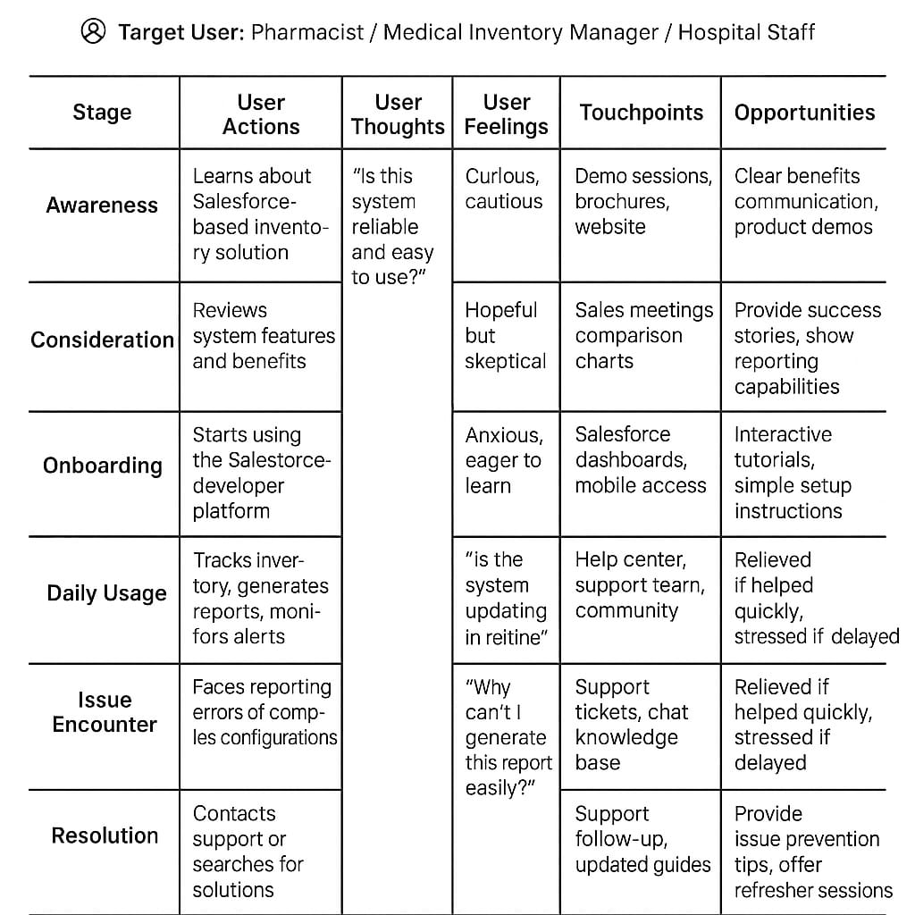

**Data Flow Diagrams:**

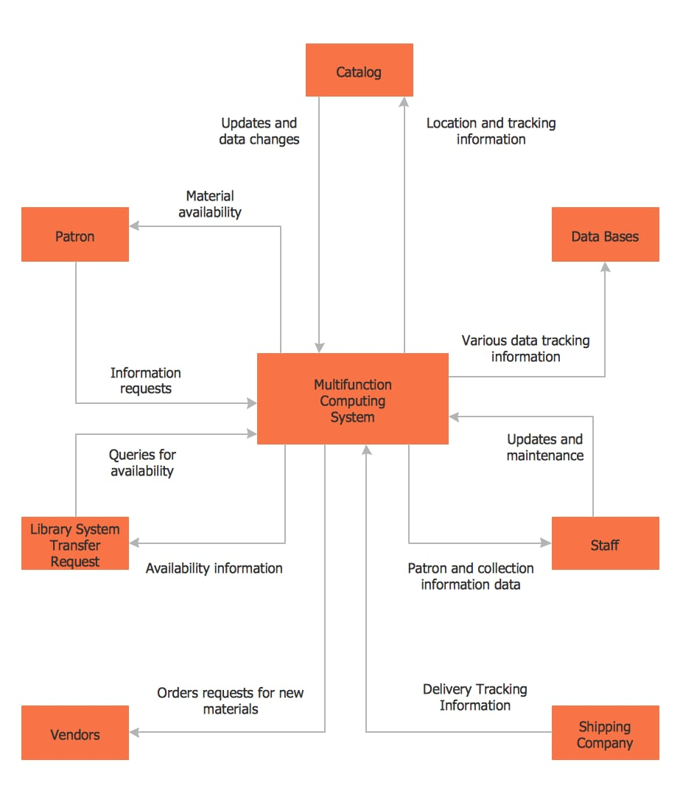

**User stories:**

|  |  |  |
| --- | --- | --- |
| **User role** | **User story** | **Priority** |
| Pharmacist | As a pharmacist, I want to receive expiry alerts so that I can remove expired medicines. | High |
| Inventory Manager | As an inventory manager, I want to track stock levels in real-time to prevent stockouts. | High |
| Doctor | As a doctor, I want quick access to medicine availability to prescribe the correct medicines. | Medium |
| Admin | As an admin, I want to generate detailed inventory reports to ensure compliance. | Medium |
| Staff | As a staff member, I want a mobile app to check inventory easily on the go. | Medium |

**Functional Requirements**

|  |  |  |
| --- | --- | --- |
| **FR No.** | **Functional Requirement (Epic)** | **Sub Requirement (Story / Sub-Task)** |
| FR-1 | Medicine Entry | Manual entry medicines  Entry through barcode  scanning |
| FR-2 | Stock Tracking | Stock Tracking  Real-time stock updates  Low stock level notifications |
| FR-3 | Expiry Management | Automated expiry via Email/SM  Expiry tracking dashboard |
| FR-4 | Reporting and Analytics | Monthly inventory usage report  Expired and near expiry medicine reports. |

**Technology Stack**

